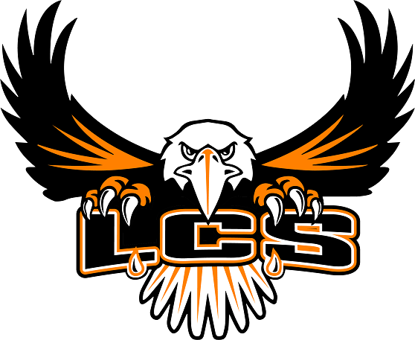
Limestone Public Schools
Limestone, Maine
School Committee Meeting
Wednesday, November 8, 2023 @ 6:00pm
Administrative Conference Room

- Roll Call

- Pledge of Allegiance

- Public Comment

- Consideration of minutes of October 11, 2023

- Adjustment to Agenda

- Reports:
- Chair
- Superintendent
- Principal
- Financial
- Spec. Ed. Coordinator
- Athletic Director
- Facilities Director

- Consideration of Agenda Items
7.1. School Committee Policies:
Code IHBAA Referral and General Education Interventions
Code IHBAA-R Referral Procedures and General Education Interventions
Code IHBAC Child Find
Code JKAA Use of Physical Restraint and Seclusion
Code JKAA-R Procedures on Physical Restraint and Seclusion
Code JKF Disciplinary Removal of Students with Disabilities
Code JKF-R Disciplinary Removal of Students with Disabilities Administrative Procedure
7.2 School Bus Bid #14
8. Adjourn

